# Supply Drivers questions

## How does production vary over time around the country?

**Figure 1 and figure 2** demonstrates a continuous increase of production over time in the United States while, consumption increment is cyclical. This difference in increase rates results in a price reduction of natural gas over time. A similar trend is observed in **figure 3** where the expected annual production volume is compared to the regular price value. Moreover, **figure 4** demonstrates that over time Texas has been the most productive state. On the other hand, Pennsylvania's natural gas production has been steadily increasing since 2002. Altogether these data suggest that a rise in natural gas production volume in the coming years may reduce its price.

Figure



Figure

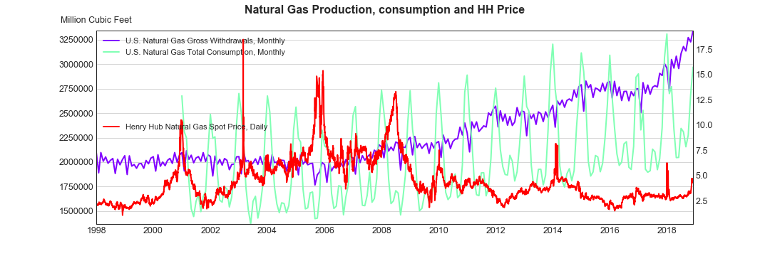

Figure

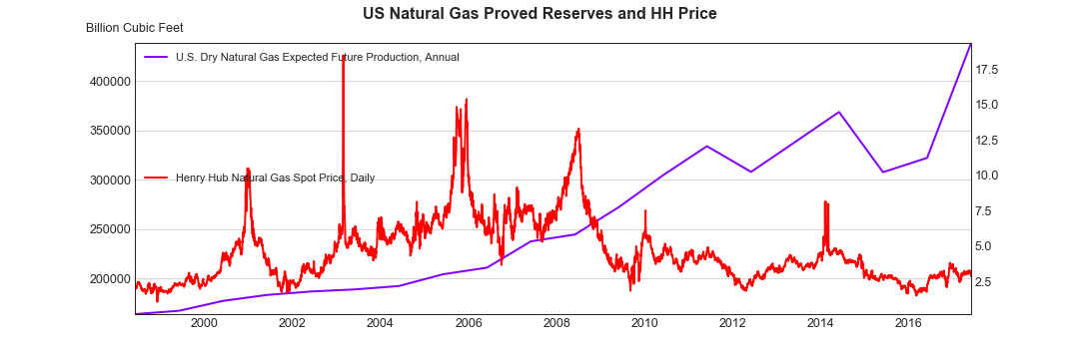

Figure



## How do natural gas imports and storage contribute to the supply over time?

**Figure 5** demonstrates that as the volume of natural gas imports decrease the export volume increase. The decrease of natural gas imports in the recent years is associated to an increase of natural gas production and reserves in the country over the pasts 10 years as observed in **figure 6**.

Figure

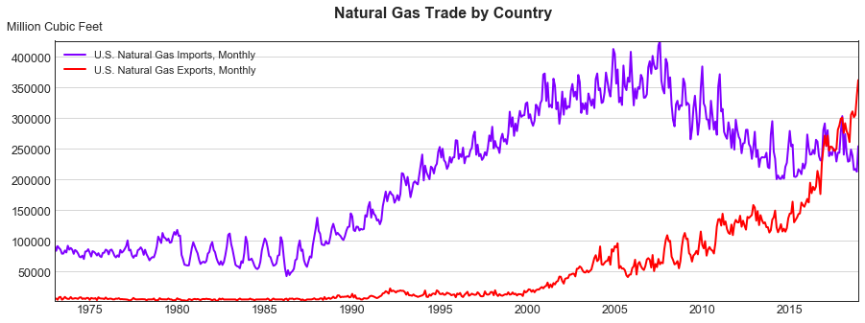

Figure



# Demand questions

## How does natural gas consumption evolve in US?

California and Texas are the states where most of the gas is consumed over time.

Figure

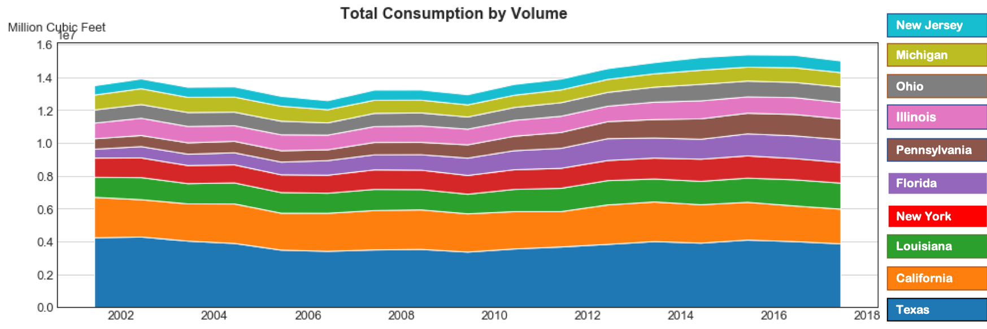

## How do natural gas exports change over time?

As observed in **figure 4**, natural gas exportation reduces as a result of increase in internal production and gas reserves.

Figure

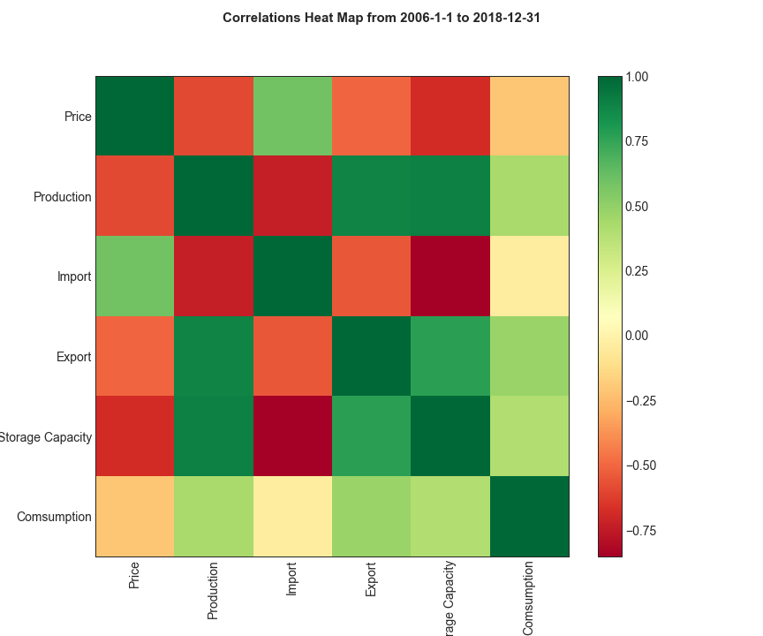

## How does seasonal effects affect gas demand?

Figure



## How does economic growth influence gas consumption?

# Price questions

## How does natural gas price relate to demand and supply drivers?

Figure



Figure

